Grade 8 Lesson 1 - The Watershed of My Town
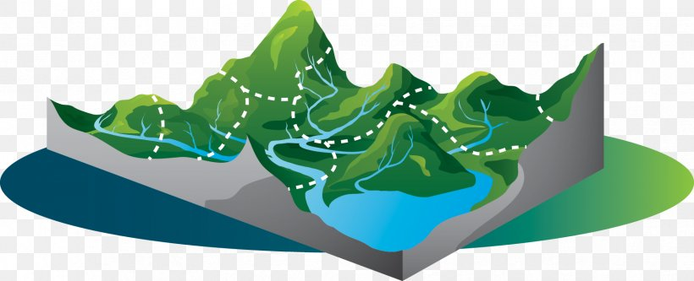
Name: ___________________________ Date: ___________
What does the land and water around you look like? Start by checking out your town/county here on these topo maps: https://www.anyplaceamerica.com/directory/nc/durham-county-37063/.
- What do people need to survive and thrive? List below all the services a town/community needs. Ex: wastewater treatment, grocery, farm, landfill, etc

- If you had a town, what would you name it? _______________________________
- Okay, time to build the town. You will need a large piece of butcher paper, a pen or pencil and multiple washable markers. Follow the instructions:
- Crumble a piece of butcher paper into a ball.

- Gently open the paper, but don’t flatten it out completely, just open it so it looks like a mountainous area.The highest points on the paper now represent mountains and the lowest wrinkles represent the valleys where there are streams and rivers.

- Choose one color of the water soluble markers to trace the highest points on the paper (or “map”). These are the mountain ridge lines.

- Choose a second color to trace the places where different bodies of water might be, such as streams, rivers, ponds, lakes, etc.

- Use the third marker color to draw all the places you’ve listed above. Label each spot with a pen or pencil.

- Choose the biggest, lowest crease to be the main river. Name the river:
______________________________________
Where will the water in your town pool? Name the structure closest to the point you think the water will “end.” This is the name of your watershed:

______________________________________
A watershed is named after this point. A watershed is all the area that will drain into a certain spot before moving off towards the ocean. The Eno River watershed is all the area around the Eno that will drain into it.
4.) Let it Rain! Use a spray bottle to gently mist your map until the water starts to move. Did your predictions match the way your water actually flowed? ______
What other observations can you make?
What could the mixing of the colors represent in a real watershed?
Weathering is the breakdown of material, and erosion is the movement of that material. This creates extra sediment (dirt) that moves into the water ways and acts as pollution. Sediment is the greatest pollutant in our rivers.
What could stop, slow or sink water on it’s pathway to prevent runoff and pollution? Check out this website to gather information about ways to prevent run off (the colors from mixing). http://cels.uri.edu/docslink/safewaterPDF/ReduceSoilErosion.pdf

Repeat this activity, creating the same town as best you can, with the new material your teacher will provide. This represents leaf litter, the natural mulch from our trees. Place this where you think it will help reduce the mixing of colors. Write your observations here after spraying your town again. What did you observe?

Write a concluding statement. Use the sentence starters to help you:
First we,
Next we,
We then,
Lastly we concluded,

