Elementary Leave Your Leaves Lesson 5
Elementary Lessons designed and created by Katie Henson
Bug Search
Introduction: When looking at a forest floor of fallen leaves, it can be hard to imagine just what’s going on underneath. In reality, those leaves are covering a large number of insects, mushrooms, and other tiny living things. While we might forget this, insect-eating animals like birds certainly don’t. Birds like chickadees, tufted titmice, and migrating warblers can commonly be seen turning over fallen leaves in search of insects. In this activity, students will play the role of hungry birds looking for insects on the forest floor.
Procedure: For this activity, you will need a large bag of toy bugs and a pile of leaves (these can either be real leaves that have fallen to the ground or fake leaves made of paper). Choose three corners of the classroom to place three different piles. Corner 1 will consist of a handful of toy bugs and no leaves. Corner 2 will consist of leaves and bugs mixed together, with approximately two handfuls of leaves and two handfuls of bugs. Corner 3 will have the remainder of the toy bugs underneath the remainder of leaves (this pile should have the largest number of bugs, but they should be completely hidden by leaves). Invite students into the classroom and have them choose a corner. On the count of 3, they will go to that corner and collect as many bugs as they can. When all bugs have been collected from each corner, have students count how many bugs they collected. Corner 1 should have the least amount of bugs, corner 2 should have a higher number, and corner 3 should have the highest number.
Questions for the class:
- Which corner did you choose and why?
- Did it surprise you that corner 3 had the most bugs?
- Why might bugs like to hide under leaves?
- How do birds know that there are bugs hidden under leaves?
- If you were a bug, would you stay in the open or hide under a leaf pile?
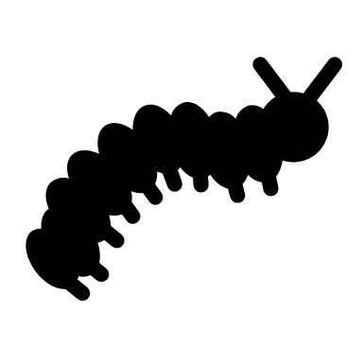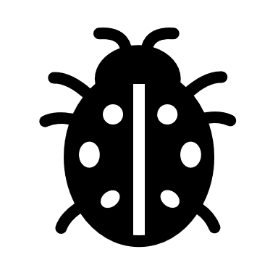 Corner 1 Corner 2
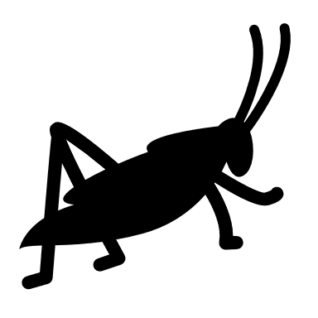

Corner 3
A representation of the proportion of bugs in each corner. Corner 1: Few bugs, but fully visible. Corner 2: More bugs, but mixed in with leaves. Corner 3: Large number of bugs, but completely covered by leaves.

