Elementary Leave Your Leaves Lesson 7
Elementary Lessons designed and created by Katie Henson
Leaf Bingo
Introduction: Leaves on the ground all look very different from each other. They can look all kinds of ways depending on which tree they came from and how long they’ve been on the ground. Here, students will try to find as many different leaf types, colors, and sizes as they can in order to win bingo.
Procedure: Print out the Bingo table (see Bingo Printout) below and provide a copy to each student. It is recommended that you randomize the squares (except the free space) so that each student receives a unique version, but this is optional.
It is also recommended that you explain terms on the sheet like “lobes” and “teeth”, or any other term that students might be unfamiliar with. Have students go out with their bingo card and look for leaves. Have them bring their leaves to show you, and upon approval, give them a stamp on the square they think their leaf matches. Note that one leaf could apply to multiple squares; for example, a leaf could have pointy tips and also be red. Each leaf they present may only count for one square, so students should think carefully about which square they want each leaf to count towards. Keep each leaf that they bring so that it cannot be used again for a different square. The first student who gets 5 squares stamped in a row (vertically, horizontally, or diagonally) will yell BINGO! and receive a prize.
Optional: have first, second, and third place prizes to keep the activity going longer, and to allow more students to win a prize.
A leaf with three colors | A leaf with a bug on it | A yellow leaf | A leaf with pointy tips | A leaf with three lobes
A leaf with round tips | A red leaf | A leaf with spots on it | 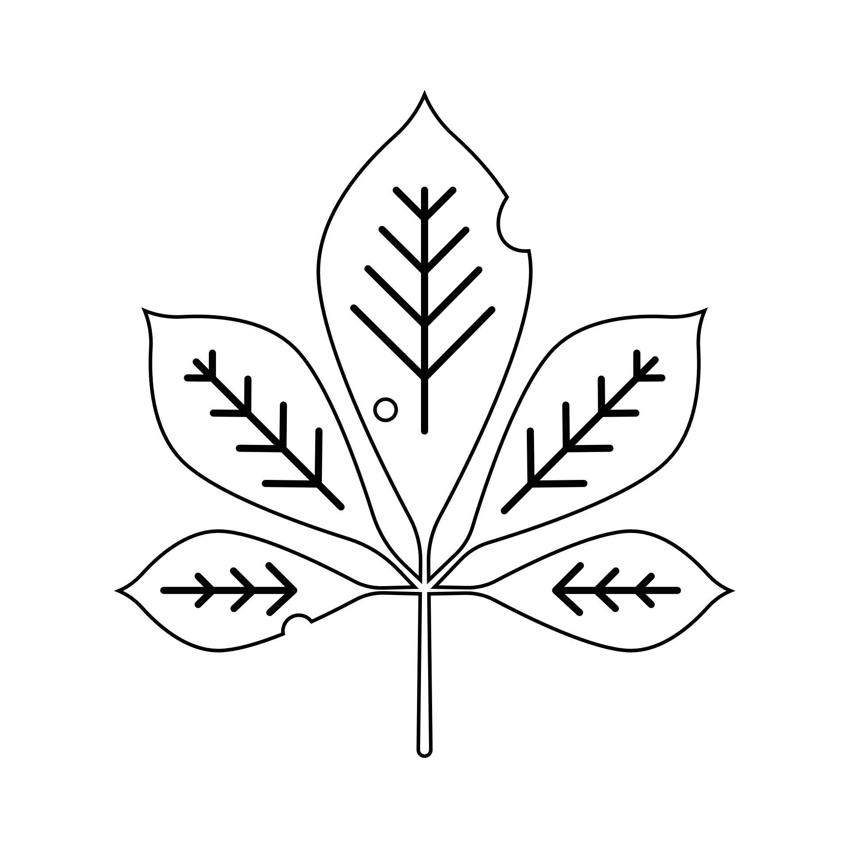 | A brown leaf
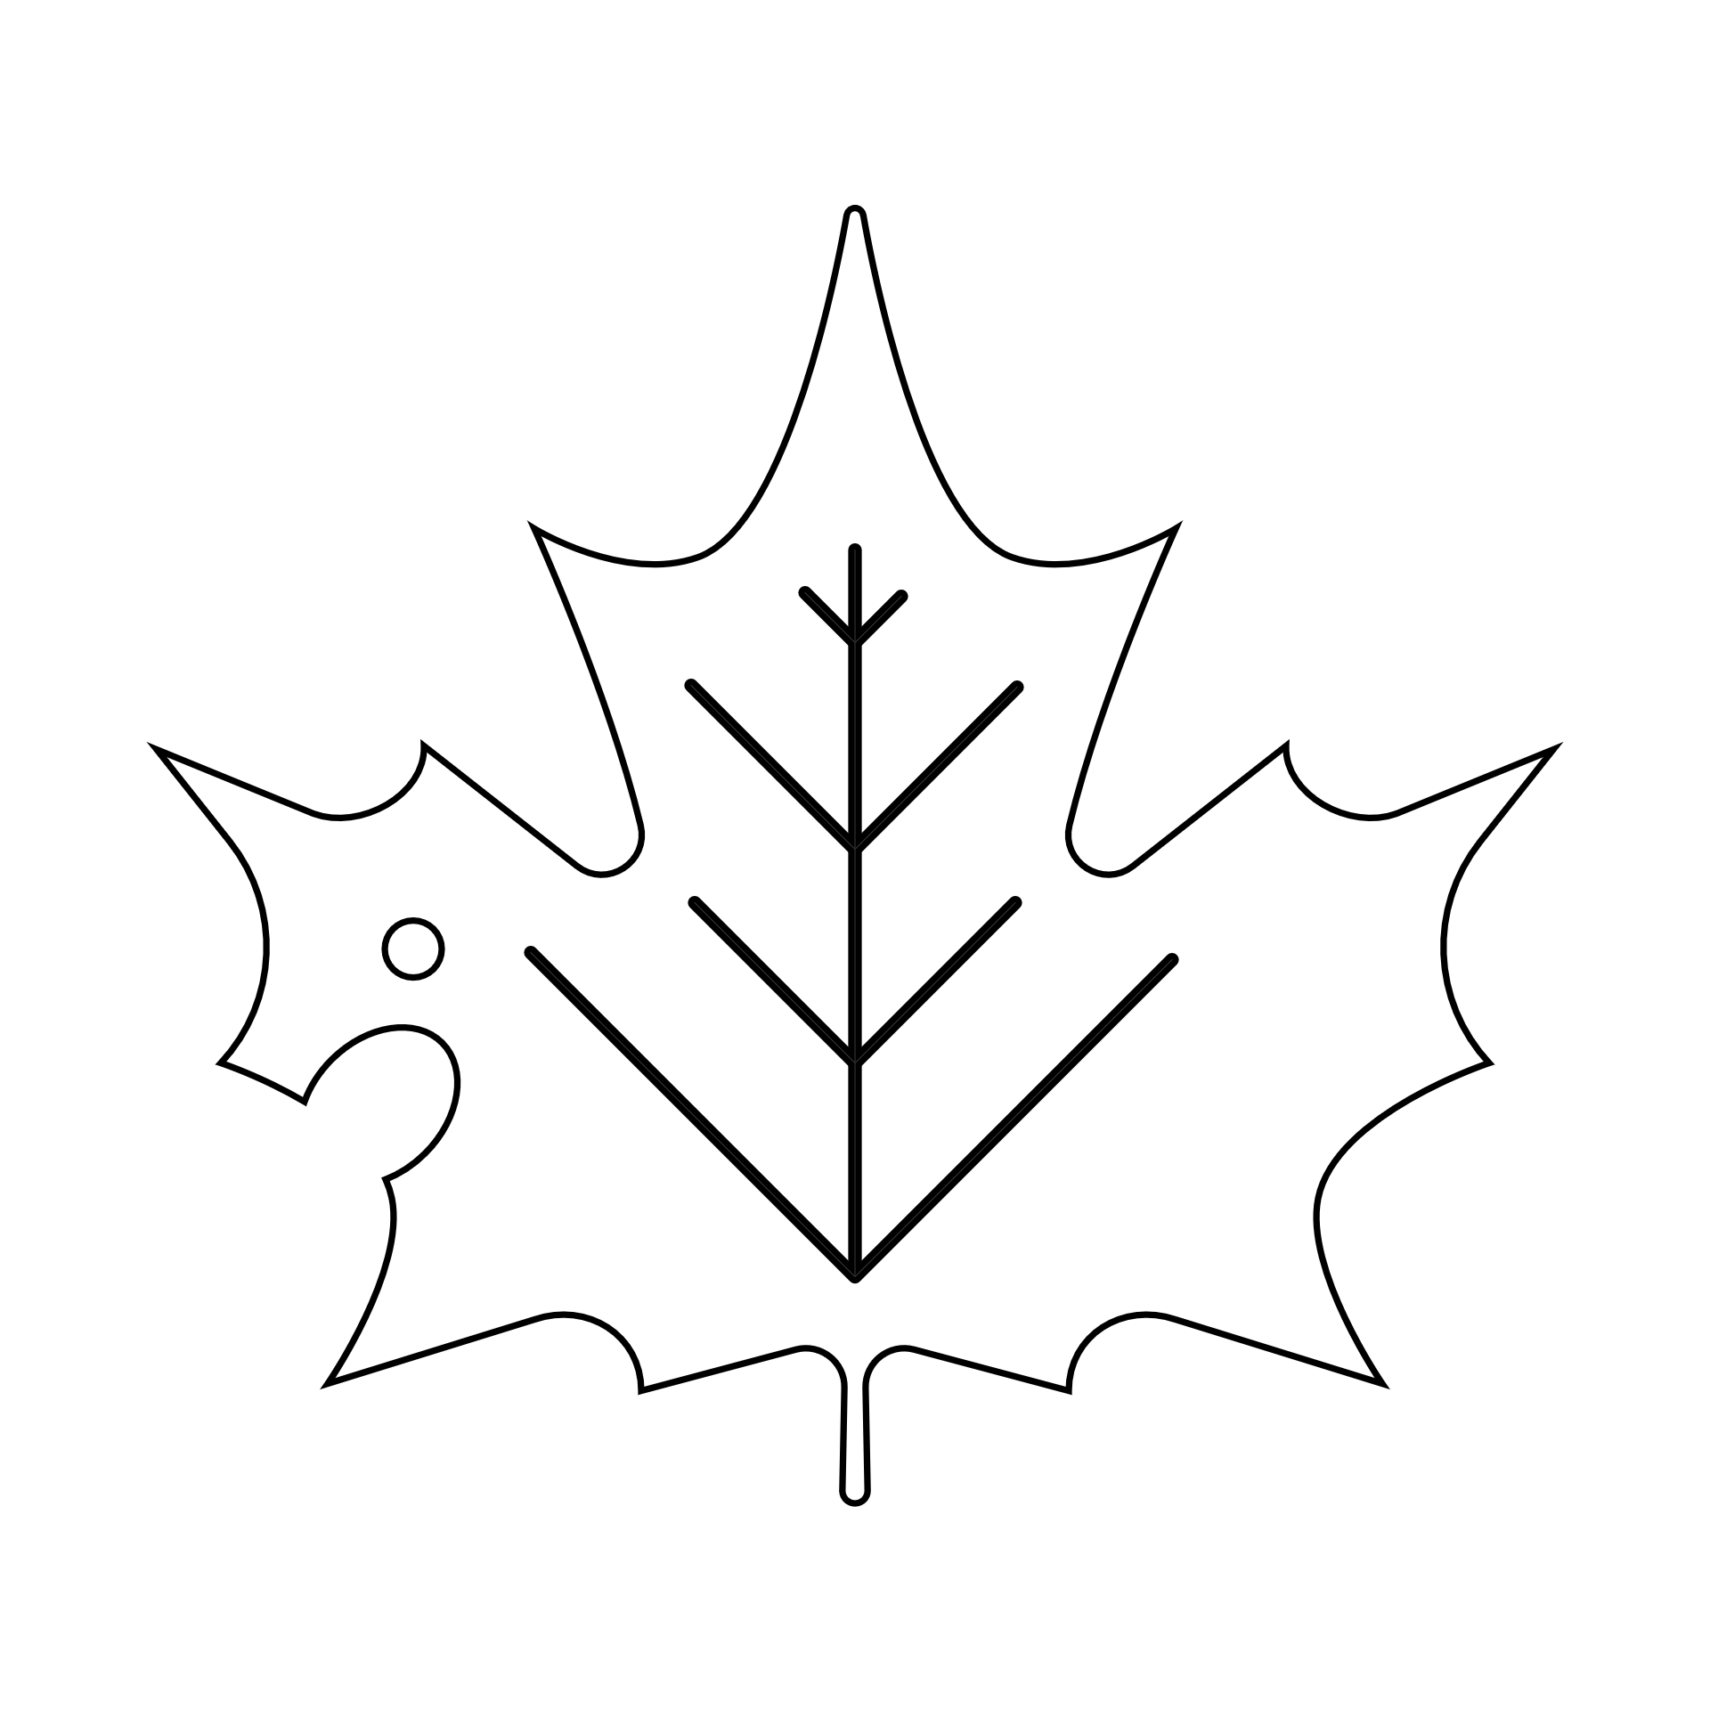 | Two leaves that look the same | Free Space | A leaf with two colors | A leaf with teeth
A leaf that’s still green | 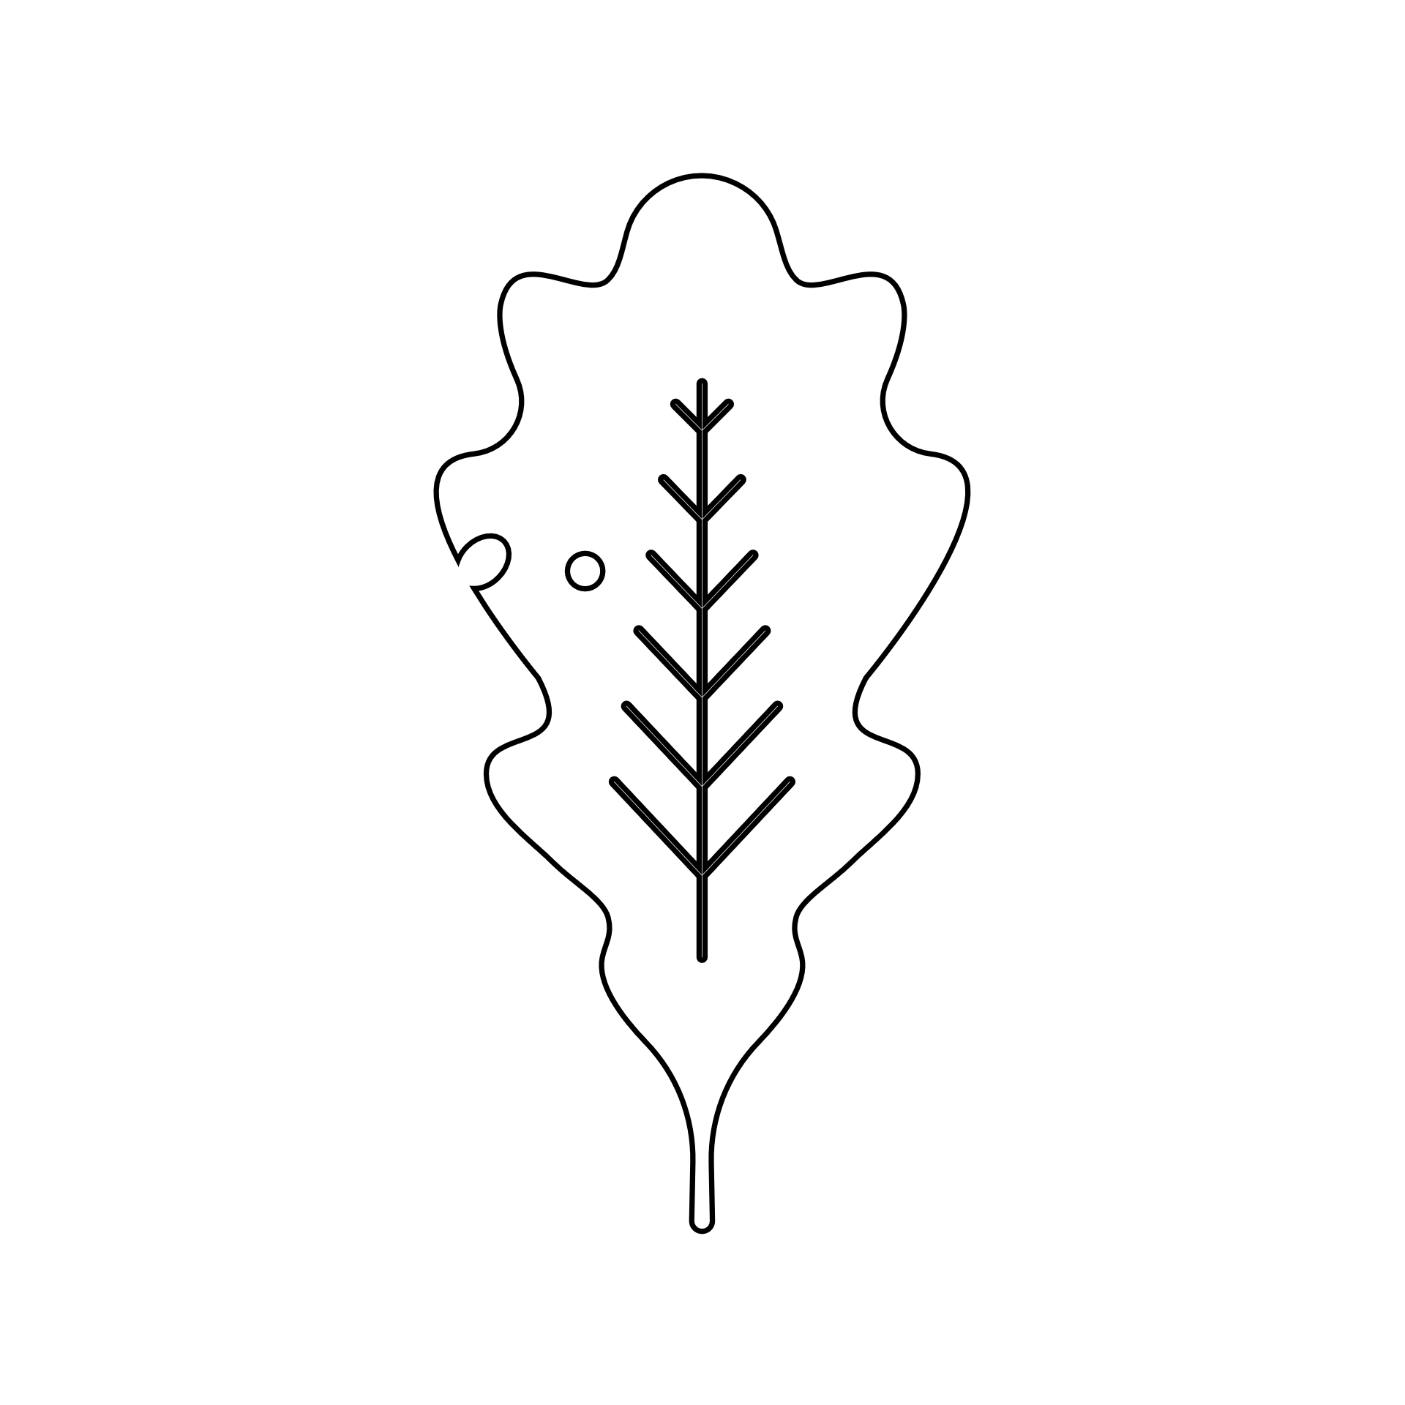 | A leaf that’s wider than your hand | A leaf with four colors | A wet leaf
A leaf with holes in the middle | A leaf that’s longer than your hand | 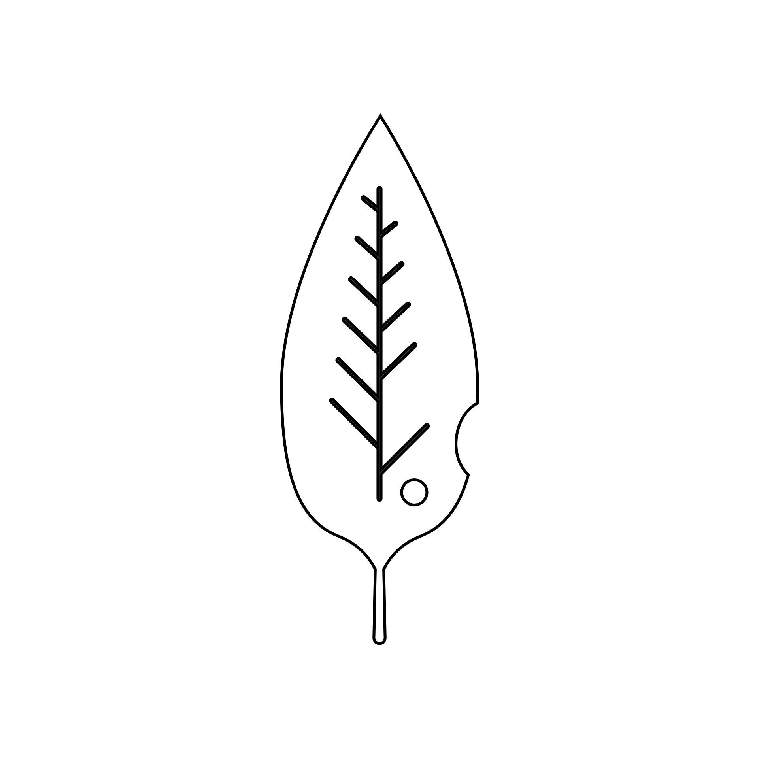 | A super dry leaf | An orange leaf

Follow-up questions:
- Was it hard or easy to find the leaves on the BINGO card?
- Where did you find most of your leaves? Near a tree, or far away from one?
- What makes leaves on the ground look so different from each other?

